1. Get inside manager container
2. Check if python is installed. Pyspark requires at least python 3.7 or above.

$ python –version

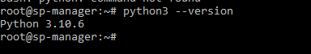

1. As we have python 3.10 , we are good to go with pyspark
2. Add spark home path in ~/.bashrc

$ nano ~/.bashrc

Add below path in the file and save.

export SPARK_HOME=/usr/local/spark  
export PATH=$SPARK_HOME/bin:$PATH

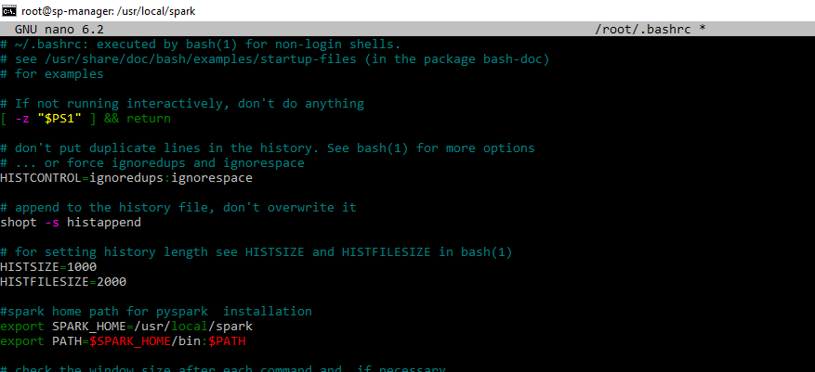

1. Restart the terminal
2. Verify pyspark

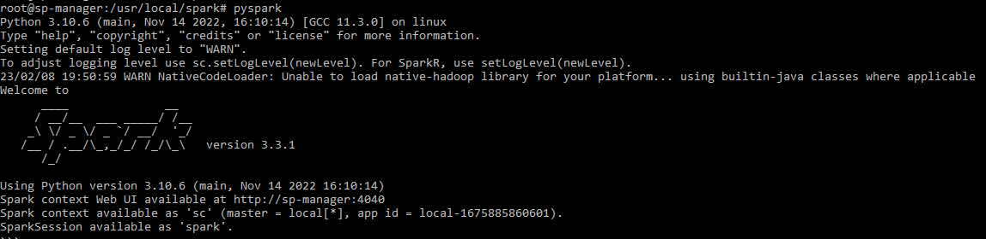

1. Install pip and jupyter

$apt-get install pip -y && pip install jupyter -y

1. Launch Jupyter with below command so that I can be accessed from host machine on port 8888

$ jupyter notebook --ip=0.0.0.0 --port=8888 --no-browser --allow-root

Use URL & token shown in the output to open jupyter notebook.

1. Use port forwarding command in local machine to open jupyter notebook

$ssh -L 6060:localhost:6060 [gprasad@10.247.62.19](mailto:gprasad@10.247.62.19)

1. Now open browser in local machine and copy URL & Token generated in step 8.

**PySpark in Jupyter**

1. Update PySpark driver environment variables: add these lines to your ~/.bashrcfile.

export PYSPARK_DRIVER_PYTHON=jupyter  
export PYSPARK_DRIVER_PYTHON_OPTS= ‘notebook --ip=0.0.0.0 --port=8888 --no-browser --allow-root’

1. Restart terminal and launch PySpark again:

$ pyspark

1. Execute a test program in Jupyter

**References**

<https://medium.com/sicara/get-started-pyspark-jupyter-guide-tutorial-ae2fe84f594f>